1998—2022年房地产开发企业房屋新开工面积情况
单位：万平方米
年 份 | 本年房屋新  开工面积 | 住 宅 | 办公楼 | 商业营业用房 | 其 他
1998 | 20387.90 | 16637.50 | 871.50 | 1938.65 | 940.25
1999 | 22579.41 | 18797.94 | 690.29 | 2198.56 | 892.62
2000 | 29582.64 | 24401.15 | 898.81 | 3034.77 | 1247.91
2001 | 37394.18 | 30532.72 | 1072.98 | 4105.40 | 1683.08
2002 | 42800.52 | 34719.35 | 1254.24 | 4926.48 | 1900.45
2003 | 54707.53 | 43853.88 | 1466.89 | 6706.80 | 2679.96
2004 | 60413.86 | 47949.01 | 1704.19 | 7790.81 | 2969.85
2005 | 68064.44 | 55185.07 | 1671.10 | 7675.47 | 3532.79
2006 | 79252.83 | 64403.80 | 2134.94 | 8473.23 | 4240.86
2007 | 95401.53 | 78795.51 | 2141.44 | 9093.89 | 5370.69
2008 | 102553.37 | 83642.12 | 2471.95 | 10040.69 | 6398.61
2009 | 116422.05 | 93298.41 | 2860.76 | 12415.03 | 7847.85
2010 | 163646.87 | 129359.31 | 3668.07 | 17472.58 | 13146.91
2011 | 191236.87 | 147163.11 | 5399.20 | 20730.78 | 17943.77
2012 | 177333.62 | 130695.42 | 5986.46 | 22006.85 | 18644.89
2013 | 201207.84 | 145844.80 | 6887.24 | 25902.00 | 22573.80
2014 | 179592.49 | 124877 | 7349.1 | 25047.73 | 22318.66
2015 | 154453.68 | 106651.3 | 6569.12 | 22530.29 | 18702.96
2016 | 166928.13 | 115910.6 | 6415.29 | 22316.63 | 22285.61
2017 | 178653.77 | 128097.78 | 6139.66 | 20483.93 | 23932.41
2018 | 209537.16 | 153485.36 | 6101.51 | 19995.39 | 29954.91
2019 | 227153.58 | 167463.43 | 7083.59 | 18936.28 | 33670.29
2020 | 224433.13 | 164328.53 | 6603.71 | 18012.32 | 35488.57
2021 | 198895.05 | 146378.56 | 5223.89 | 14105.53 | 33187.08
2022 | 120107.43 | 87748.71 | 3176.1 | 8155.03 | 21027.59

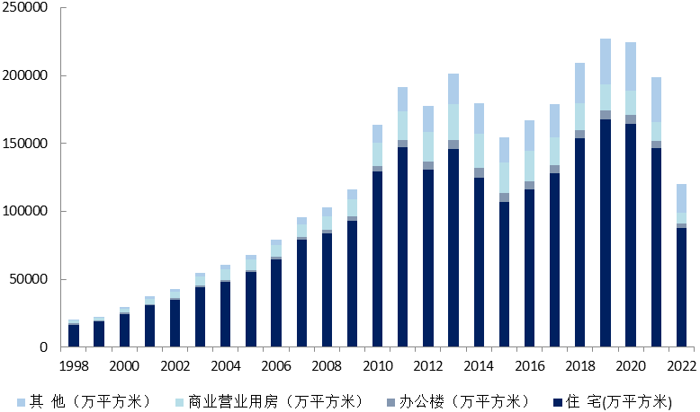
1998—2022年房地产开发企业房屋新开工面积情况

